L/N FFA SILENT LABOR AUCTION
February 10th LN Raiders vs. Harvard
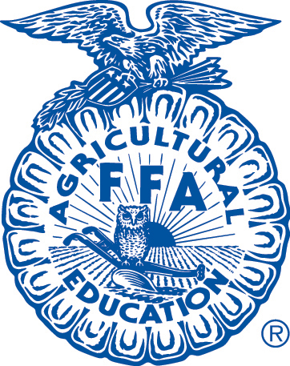
32 students with awesome work skills
All Proceeds will go towards FFA State Convention!!
4 Hours Labor - $30.00 Base price
6 Hours Labor - $40.00 Base price
We will accept bids throughout the Girls Varsity Game and until the Boy’s Varsity Basketball Game 1st Quarter
Announce winners at Half time!!!
*Special Monsanto Recognition* will be held during halftime for the American Farmers Grow Communities Donation!!

